Contents:
The 2017 CPD System – Log Book
(for use from January 2017 onwards)
- Personal Development Plan
- Activity Log for …………… [year]
- Summary of Times Spent on each of the main CPD Categories
- Reflection / Discussion

Refer to the GSL Website, CPD pages for links to the following documents
- CPD Log book (this document) MS Word File
- Guidelines for Completing a Compliant CPD Record (including the Mind Map and a CPD Category rapid lookup table to assist in compiling the Activity Log) PDF file
- CPD Mind Map (standalone version) PDF file
- A New CPD System for GSL – presentation to RGs (with presenter’s notes) PDF file
- The Geological Society’s CPD System – 2017 onwards (background information) PDF file

Personal Development Plan (PDP)
CPD Year (example – Year 2: (2017)) | 5-year Career Aspiration Plan (CAP) period (example – 2016 – 2020
My CPD objectives for the year ahead are:
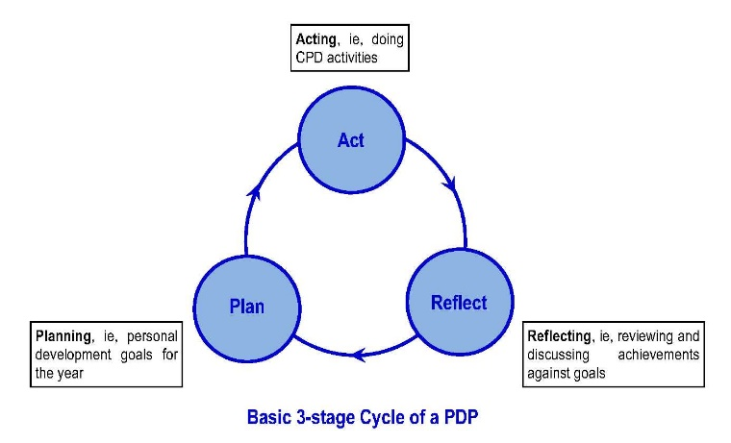

Extend this box if necessary

Table 1 ~ Activity Log for …………… [year]
Example
Date (dd/mmm) | Category* | CPD Event – Brief Description | Time spent (hrs) | Evidence
10 Jan | IL | GSL WSW Regional Group Meeting: Dr A N Other The influence of crinoid assemblages on the stability of excavations … | 5 | Annotated flyer
Add rows to the table as necessary

Table 2 ~ Summary of times accumulated in each of the main CPD categories
Name: ………………………………………………. |  |  |  | CPD Year: …………………………. |  |  | Minimum total  hours required: ………………
CPD Category | On-the-Job  (OtJ) | Formal Learning  (FL) | Informal Learning  (IL) | Professional Practice  (PP) | Self-directed Study  (SD) | Other  (O) | Total time | Carry over
CPD hours

Table 3 ~ Minimum amounts of annual CPD for Chartered Fellows in various states of work
Work Status of Fellow |  | Min annual CPD, total hr | Min total CPD hours in On-the-Job learning | Min total hours on Career Development, excl On-the-Job | Max annual carry-over of excess hr
1 | Early career (pre-Chartership) Fellows | ≥ 90 | 30 | 30 | 20
2 | All Fellows in full time employment, or on sabbatical leave | ≥ 90 | 30 | 30 | 20
3 | All Fellows in part time employment (eg, work sharing) | ≥ 50 | 16 | 16 | 10h
4 | All Fellows on extended leave (carers, parental leave, prolonged illness, etc) (but with special pre-arranged GSL dispensation, 50% of these hours may, exceptionally be allowed) | ≥ 40 | 0 | 20 | 8h
5 | Retired Fellows offering occasional professional services, and who wish to retain their chartered status, and unemployed Fellows | ≥ 50 | 0 | 0 | 10h
6 | Retired Fellows not offering professional services, and who do not wish to retain their chartered status | Optional | 0 | 0 | —
NOTES:
Once the minimum total hours have been achieved, spread across On-the-Job learning, plus at least 2 other main categories, any additional time can be spread as desired

Reflect
Reflection, ie, a review and discussion of achievements against goals set at the start of the year.
Extend this box if necessary
Please keep this Log Book in a safe place, because it may be required as part of a CPD submission for audit

